Problem Set 11 – Two-Way Analysis of Variance

Problem 1 (15 points)
Please access the Retention data. These data and the context are borrowed from Purdue University. Here are the details, quoted from the Purdue source:

Iron and Zinc fortification of milk-based fruit drinks are common practice. To better understand the effects of drink fortification on the cellular retentionof iron, researchers conducted an experiment by fortifying milk-based fruit drinks with low and high levels of iron (Fe) and zinc (Zn). The drinks were digested in a simulated gastroinatestinal tract and cellular iron retention was measured (mg Fe/mg cell protein).

Please answer each of the following question. So that your answer remains focused, you are to include ONLY the item(s) requested (else, your earned credit will be reduced).

(15 points) A colleague in your department performed a two-way ANOVA on these data and concluded that “both Iron and Zinc tested as important” for cellular iron retention. They have asked if you agree. The results of their JMP output are displayed below. Following that output, and using 100 words or less, give a well-thought out answer to your colleague about the importance of these two factors.
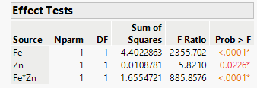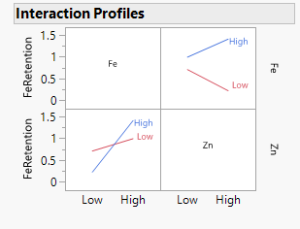

Problem 2 (35 points)
Please access the GTL data which present the results of an experiment conducted to study the influence of the operating temperature (100˚C, 125˚C and 150˚C) and three faceplate glass types (A, B and C) in the light output of an oscilloscope tube. They are from Design and Analysis of Experiments, 8th edition, by Douglas Montgomery.

Please answer each of the following questions. So that your answers remain focused, you are to include ONLY the item(s) requested (else, your earned credit will be reduced).

- (5 points) Fit a two-way ANOVA model with light output (continuous) as the response and temperature (character) and glass type (character) as factors. Include an interaction term. Copy and paste the Effect Tests table and the Interaction Profiles plot below.

- (5 points) Refer to part a. In 100 words or less, explain whether the effect of ‘operating temperature' is dependent on ‘glass type’.

- (5 points) Fit a two-way ANOVA model with light output (continuous) as the response, and temperature (character) and glass type (character) as factors. However, ONLY include glass types A and B. Do NOT include type C. Include an interaction term in the model. Copy and paste the Effect Tests table and the Interaction Profiles plot below.

- (5 points) Refer to part c. Just by looking at the Interaction Profiles plot (a plot of the treatments means), using 100 words or less, defend the Glass-Temperature combination that would likely produce maximum light.

- (5 points) Refer to part c. Take an alpha level of 0.05. In 100 words or less, explain why you should drop the interaction term and rerun the model.

- (10 points) Refer to part d. Rerun the model (no type C glass) without the interaction term. In 100 words or less, explain whether Glass Type or Temperature Level, or both, are important.

